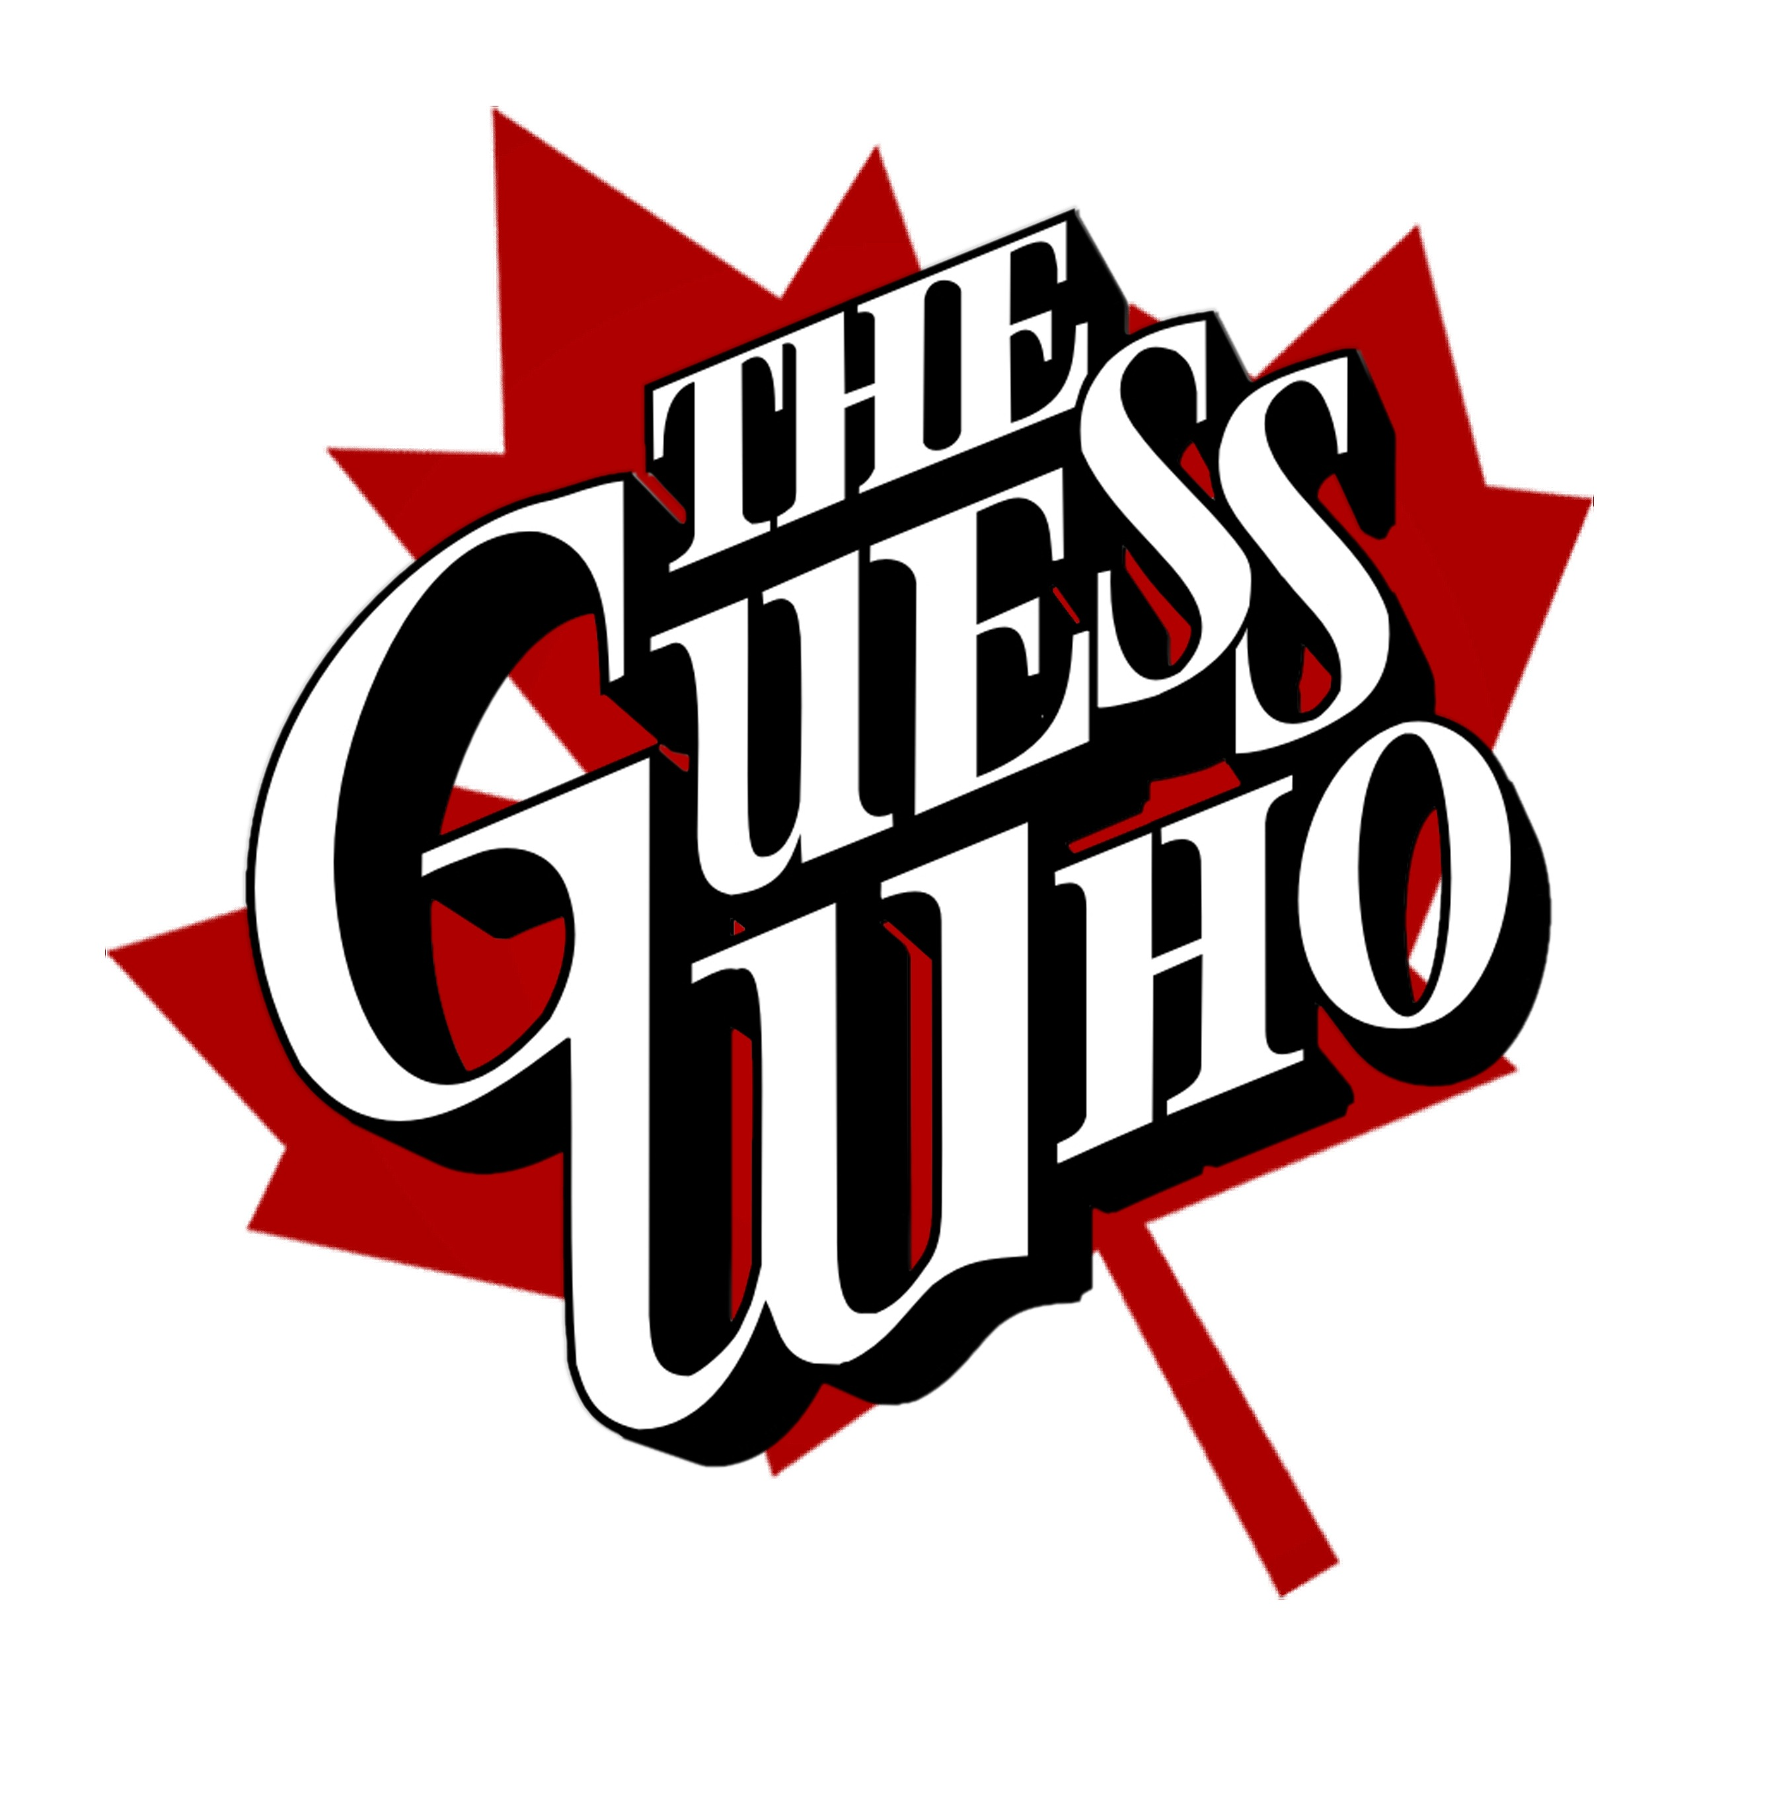

The Guess Who, the band that became Canada’s first international rock music superstars, began in 1962 in Winnipeg as Chad Allen & The Reflections. Including members Randy Bachman (guitar), Jim Kale (bass) and Garry Peterson (drums), Chad Allen and the Reflections had become Chad Allen and the Expressions by the time they recorded a cover of “Shakin’ All Over”, released by Quality Records in 1965. The song was a #1 single in Canada and reached #22 in America. Burton Cummings joined the group that same year, replacing the keyboard player and sharing lead vocals.

Quality Records released the group’s first single and album, Shakin’ All Over, in a plain white record jacket with only the question “Guess Who?” written on it. The marketing ploy capitalized on curiosity and the promise of another British Invasion band. It worked. After selling two million copies the band had its trademark name: The Guess Who. Following the success of Shakin’ All Over, the band toured the U.S. as part of Dick Clark’s Caravan of Stars Road Revue and in 1967 they landed a regular spot on the CBC-TV show, Where It’s At.

Experimenting with the sounds of freedom, psychedelic, and garage rock that were filtering across the border from Minneapolis, The Guess Who traveled to Minneapolis, where they did their first recordings at K-Bank Studios. Their song “His Girl” gave the band a Top 20 hit in England, an offer to sign with London-based King Records, and the opportunity to tour. They immediately left for the U.K. After just one album, the band quit King Records and returned to Canada. After recording the promotional album A Wild Pair (with The Staccatos on the flipside) for Coca-Cola and appearing on the TV show Let’s Go, the homecoming of The Guess Who was marked by the sale of their Quality Records contract for $1,000 to Nimbus 9, owned by producer Jack Richardson.

Richardson believed so strongly in The Guess Who that he mortgaged his home to finance the recording of the album, Wheatfield Soul, which was released in 1968. The first single, “These Eyes”, reached #1 in Canada, and earned the band a U.S. contract with RCA Records. Heralded as the beginning of the Canadian Invasion, “These Eyes” reached #3 in America in 1969 with total sales of more than one million copies. Their second album for RCA, Canned Wheat by The Guess Who, also released in 1968, contained the Top 10 hits “Laughing”, “No Time”, and the Top 40 hit “Undun” (the B-side of “Laughing”).

Ironically it was “American Woman”, from March of 1970, which gave The Guess Who a #1 single in the U.S. and unseated The Beatles for three weeks straight. The Top 10 album, also entitled American Woman, containing the hits “No Sugar Tonight/New Mother Nature” (the B-Side of American Woman), also went to #1 in Billboard for three weeks.

This new trend of having double sided singles both going to #1 was a rare occurrence, only achieved by; Elvis, The Beatles, The Rolling Stones, The Guess Who, and Creedence Clearwater Revival.

The popularity of the band earned them an invitation to perform at the White House before Prince Charles and the President and Mrs. Nixon, although she requested that the band not perform “American Woman.” It was during this peak of The Guess Who’s success that Randy Bachman decided to leave the band (replaced by guitarists Kurt Winter and Greg Leskiw); he formed Bachman Turner Overdrive shortly thereafter. Over the next few years the group continued to chart with the singles “Hand Me Down World”, “Share The Land”, “Bus Rider”, “Rain Dance”, “Albert Flasher”, “Star Baby” and “Clap for the Wolfman” (which reached #6 on the Billboard Charts), and the album Greatest Hits. In all, the group has 14 bona fide Top 40 Hits to its credit!

After 10 years with the band, Burton Cummings left in 1975 to pursue a successful solo career. The original members of the The Guess Who appeared sporadically over the ensuing years: Jim Kale continued the band with new members through the late 70’s; Randy Bachman and Burton Cummings toured together in 1983; there was a brief reunion from which an album and concert video were released in 1985; and the band appeared together when they were inducted into the Canadian Recording Arts & Sciences (CARAS) Hall of Fame in 1987.

In 1999 The Guess Who returned to their Winnipeg roots, responding to a personal request from the Premier of Manitoba, to appear at the closing ceremonies of the Pan Am Games. The reunion was performed in driving rain before a combined live and television audience of nearly a million people. The excitement and personal enjoyment found in performing together again as The Guess Who inspired them to consider touring across Canada. Months of reunion rumors were finally confirmed in March 2000 when the Running Back Thru Canada tour announced more than 24 performances in over 22 cities across Canada.

The emergence of “classic rock” radio stations throughout North America has broadened the base of the group’s loyal followers to include more of the baby boomer generation, on down to today’s teenagers. A typical audience at a concert by The Guess Who will contain fans from 16 to 60 years old. The popularity of The Guess Who has increased tremendously due to the strength and the highly regarded reputation of their live concert performances.

Although membership in the group has changed through the years, they have remained musically consistent behind the strengths of original members Jim Kale (bass and vocals) and Garry Peterson (drums and vocals); and backed by Derek Sharp (vocals and guitars), and Leonard Shaw (keyboards, flute, sax and vocals) and Will Evankovich (guitars and vocals). As they perform hit after hit in concert, it is easy to see and hear why The Guess Who remain one of today’s most sought after touring attractions.

